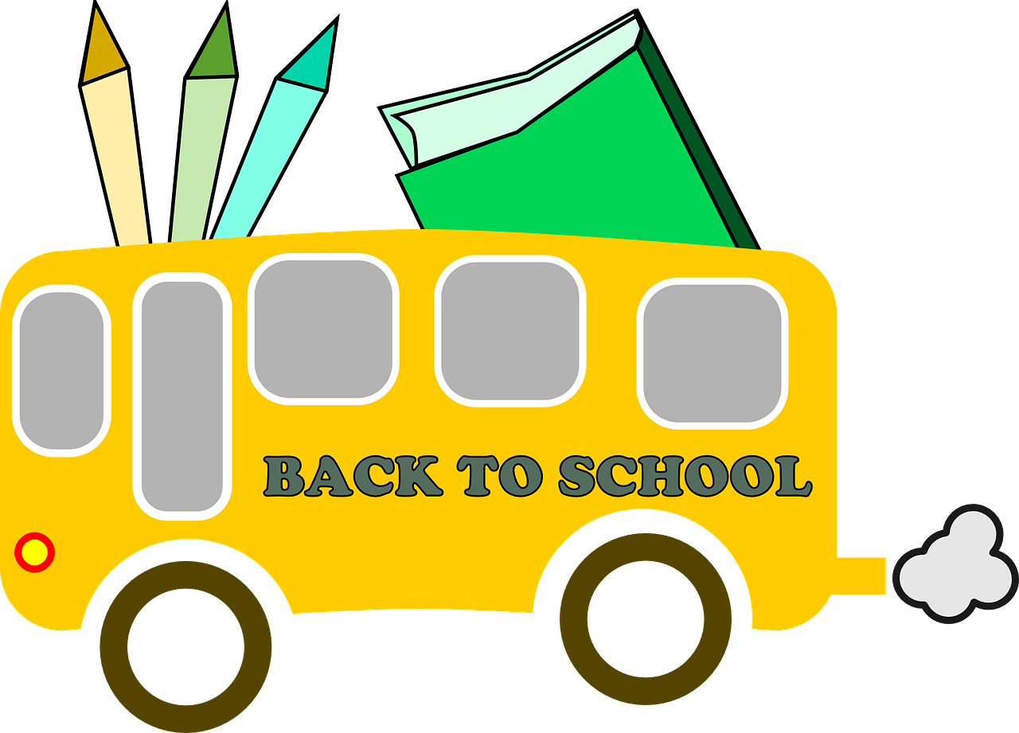
Sunnyside Elementary
Mrs. Lee’s 2nd Grade
Supply List

  - 1 backpack
  - Earbuds or headphones (no wireless headphones)
  - 1 school pencil box (No pouches please)
  - 2 packages of #2 pencils (no mechanical pencils)
  - 2 boxes of crayons with names on them please
  - 1 pair of Fiskar scissors
  - 4 glue sticks
  - 2 folders with pockets
  - 1 Plain White three ring binder with the clear front plastic pouch
  - 2 large pink erasers
  - 1 spiral notebook (wide ruled)
  - 1 roll of paper towels
  - 1 box of tissues
  - 1 container of wet wipes Clorox or Baby wipes will work!
  - 1 bottle of Hand sanitizer

